**ALM for Client**

1. **Double click on it**

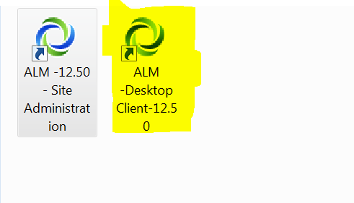

1. **user name: alm12, Password: alm12 then click authenticate**

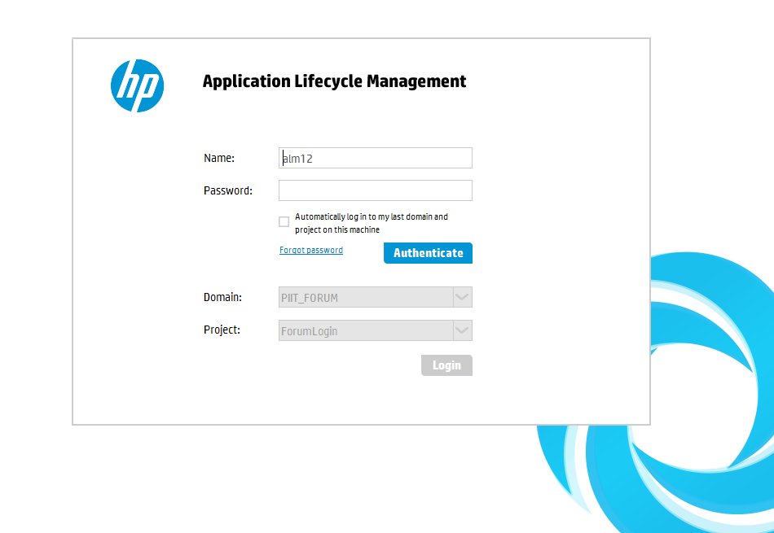

1. **select your domain and project**

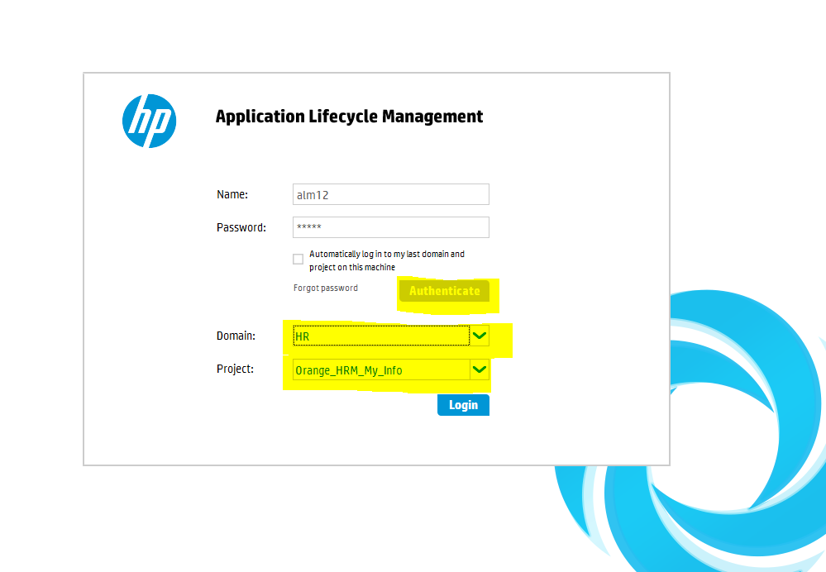

1. **You should be able to see user interface**

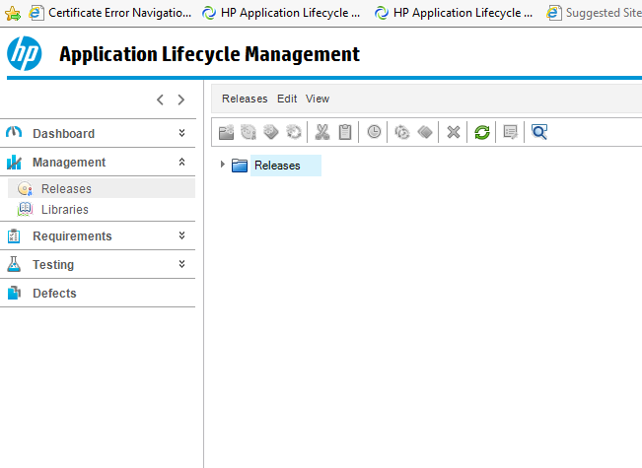

1. **You can see the domain name, project name and username you are signed in with**

**And this top section is called MASTHEAD**

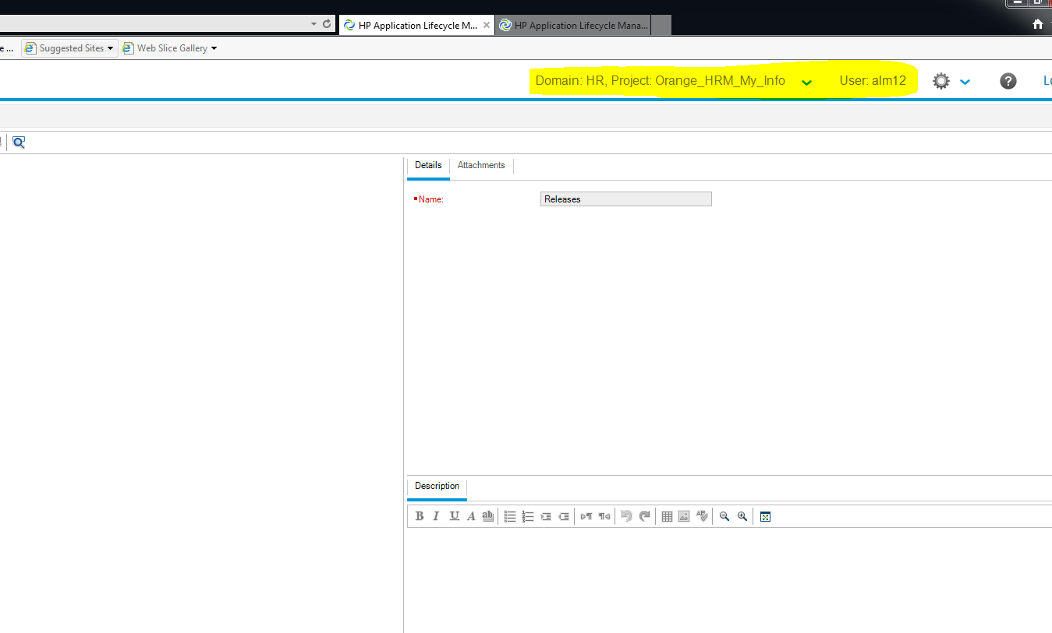

1. **Dashboard module is usually used by project manager, client or business analyst to check the graphical view of the project, how many defects there are, how much time left, how many requirements are covered.**

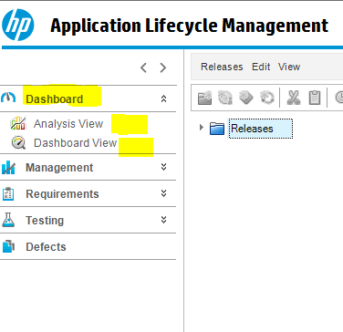

1. **How to create release**

**Management module has releases where you can add releases and cycles**

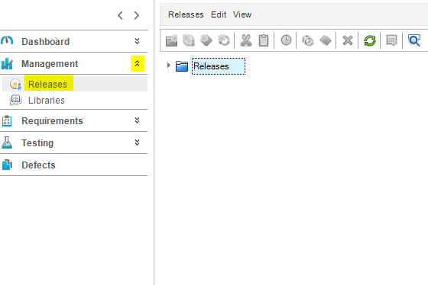

1. **You can create a release Folder related to the project**

**Click on new release folder icon**

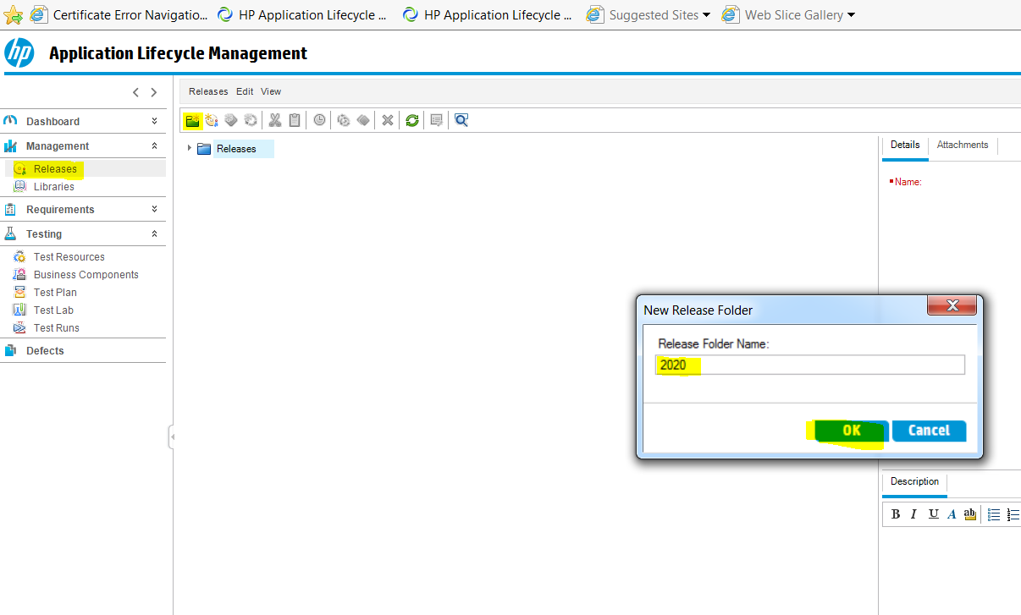

1. **After Creating the Release folder, you can start creating releases in that folder for that project**

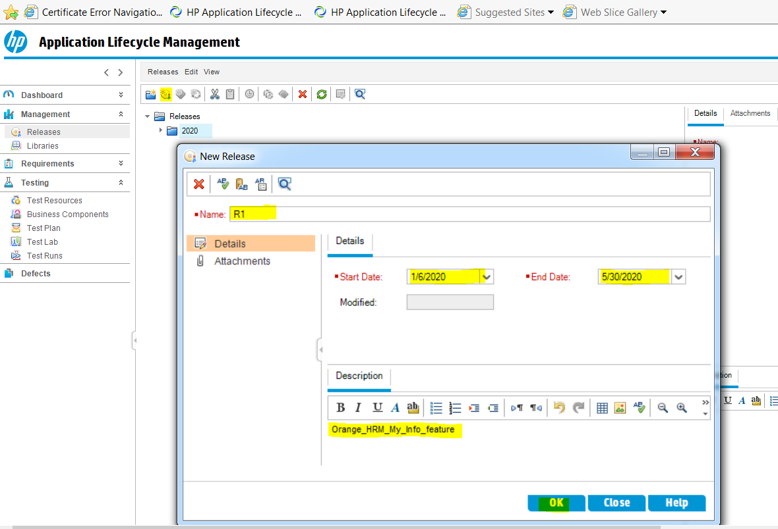

1. **Then you can click on attachments and add attachments, description or delete attachments**

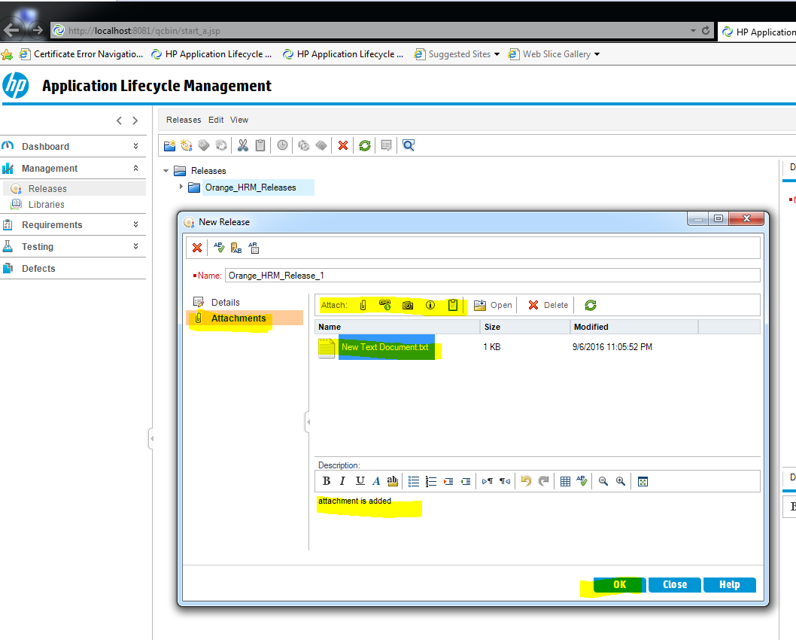

1. **You can see how you are release coming together**

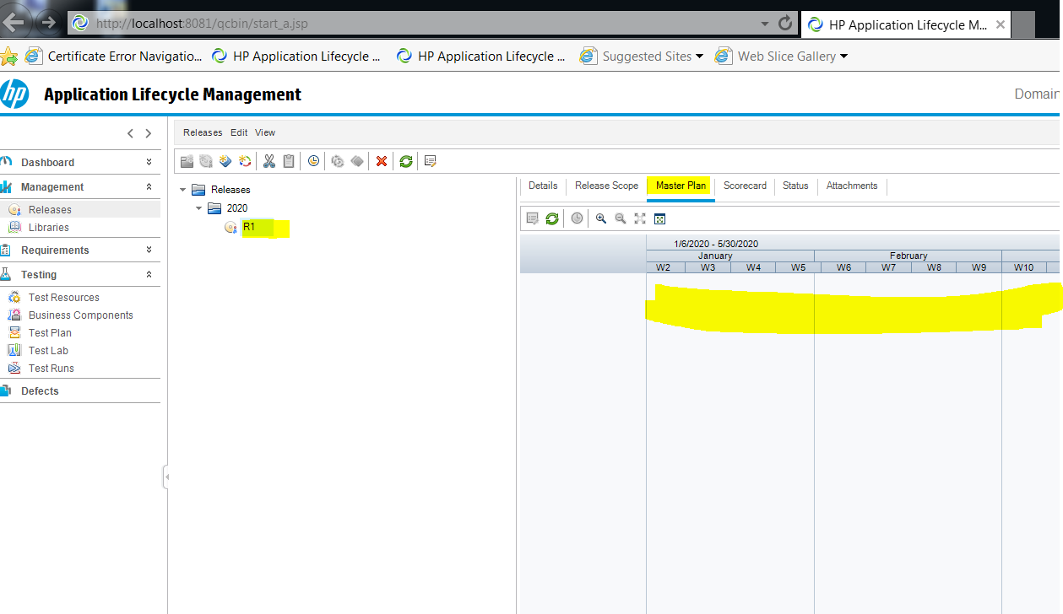

1. **Additional details about the release , total day spent remaing days etc, You can see in status**

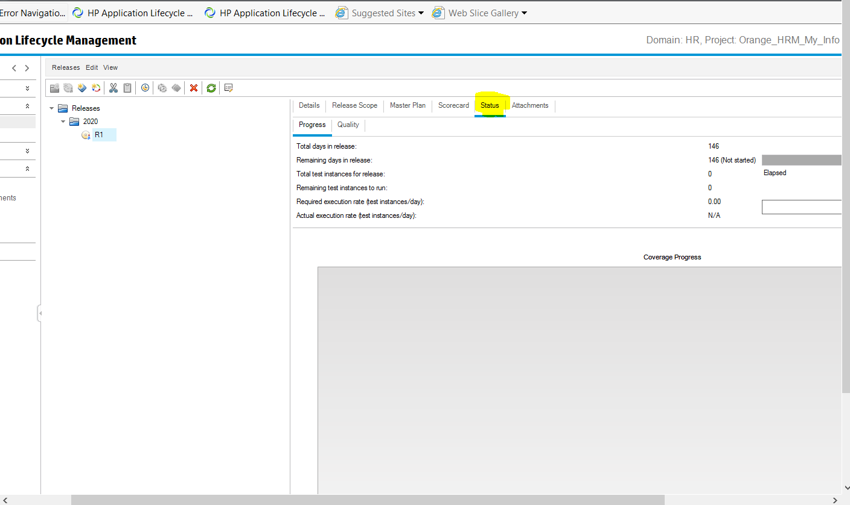

**13 – Create a cycle by clicking on small new cycle icon**

**Cycle is a child of the release**

**Usually release is smaller time under a release**

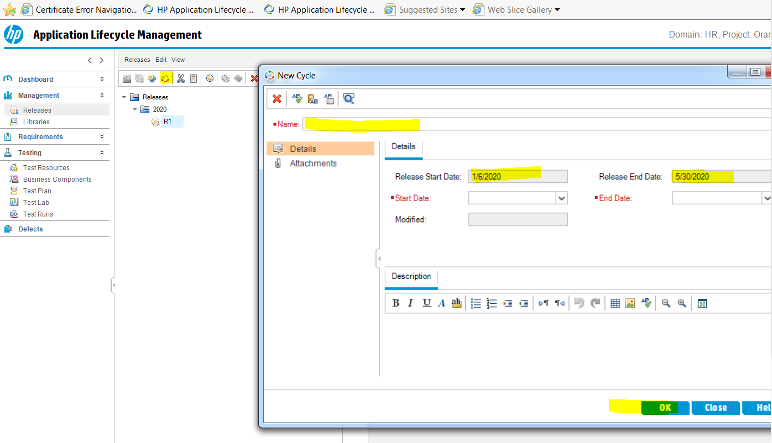

**Put name dates description and click ok**

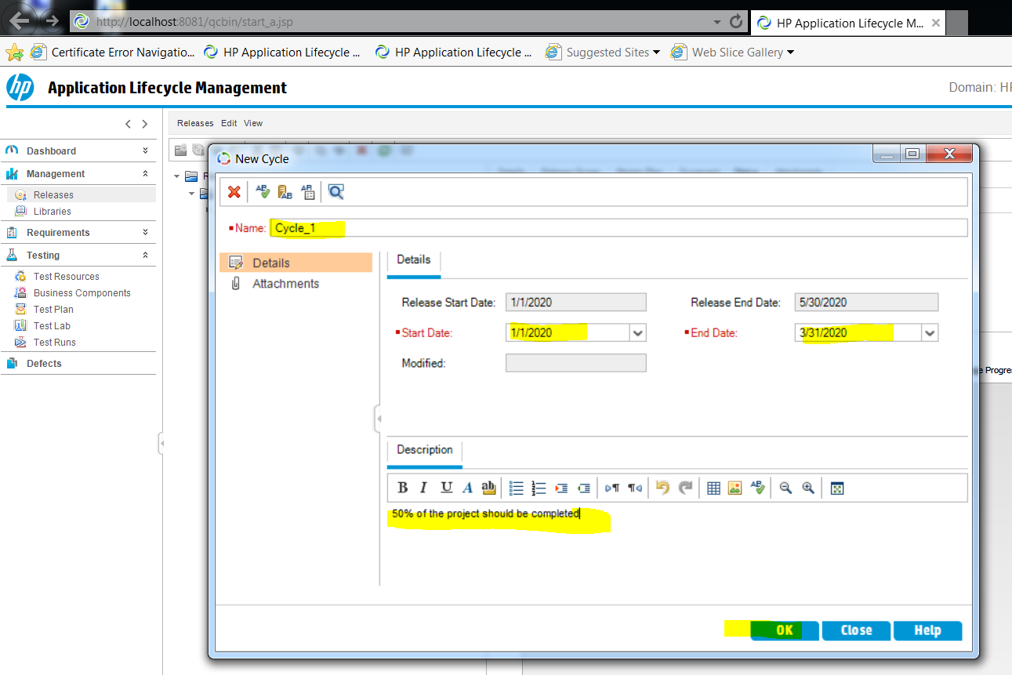

**14-Then click on R1 then new cycle icon**

**And create another cycle**

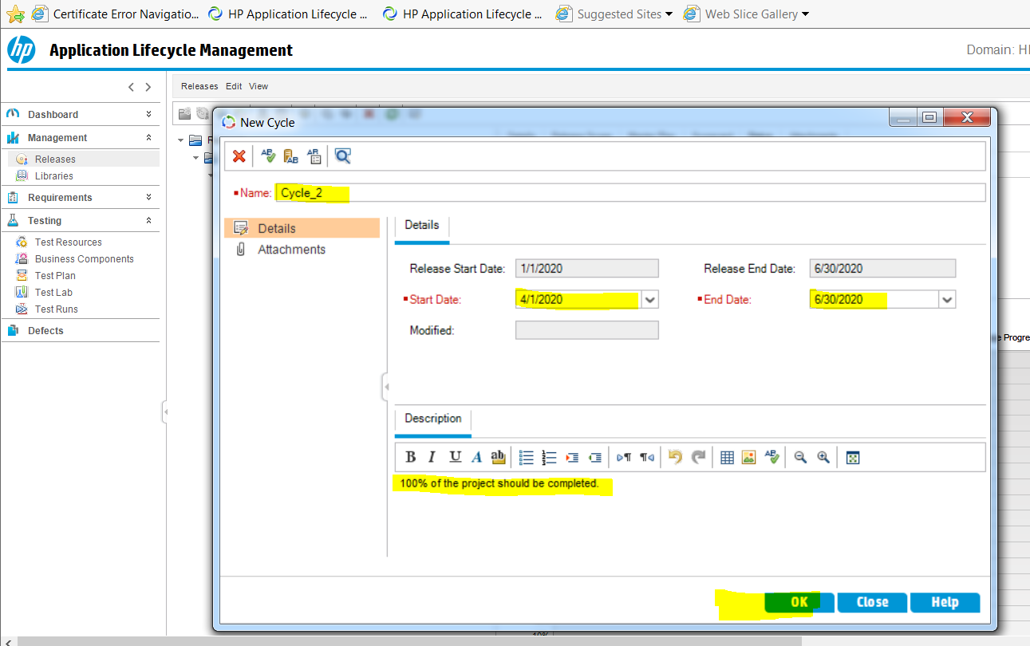

**15- creating another release**

**You need to click on release folder first**

**Then click on new release icon to create**

**Then fill the details about your release**

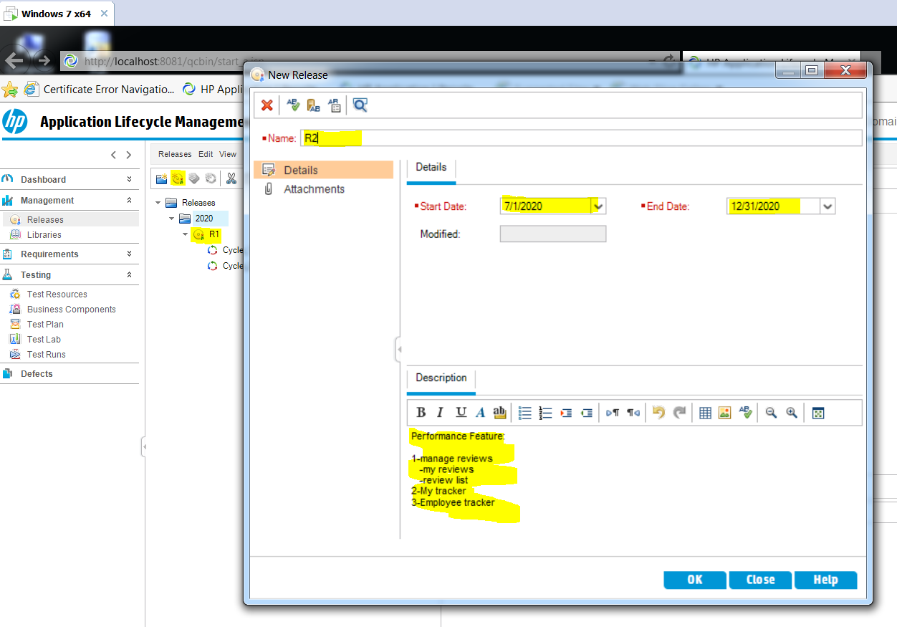

**16- now we created a release with 6 features**

**So We will create 6 cycles and give one month time for each feature in these cycles**

**CYCLE_1**

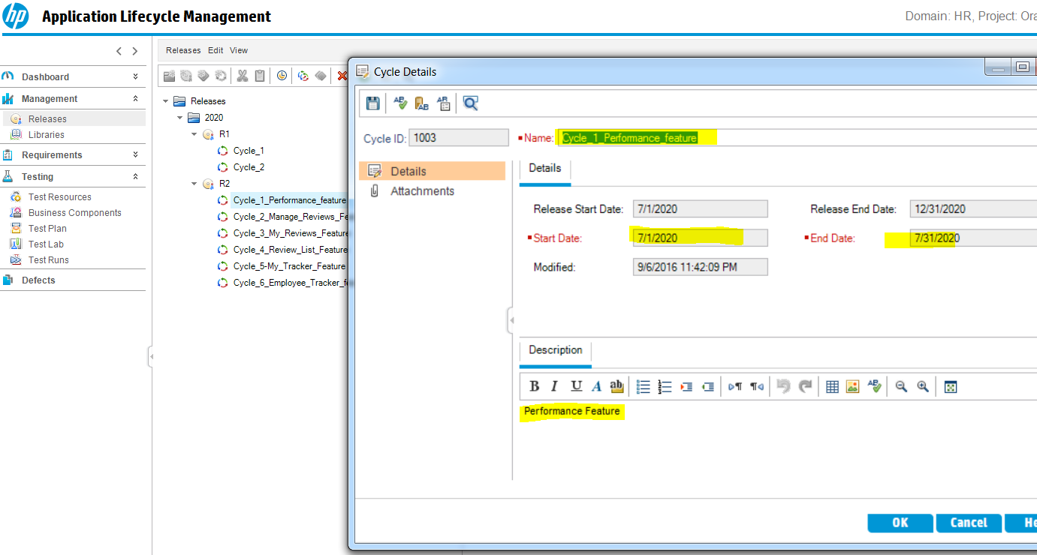

**CYCLE_2**

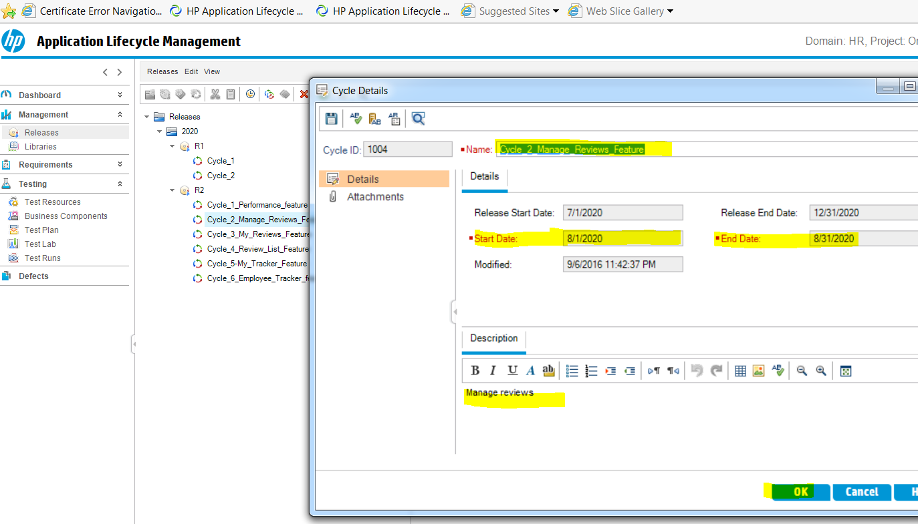

**CYCLE_3**

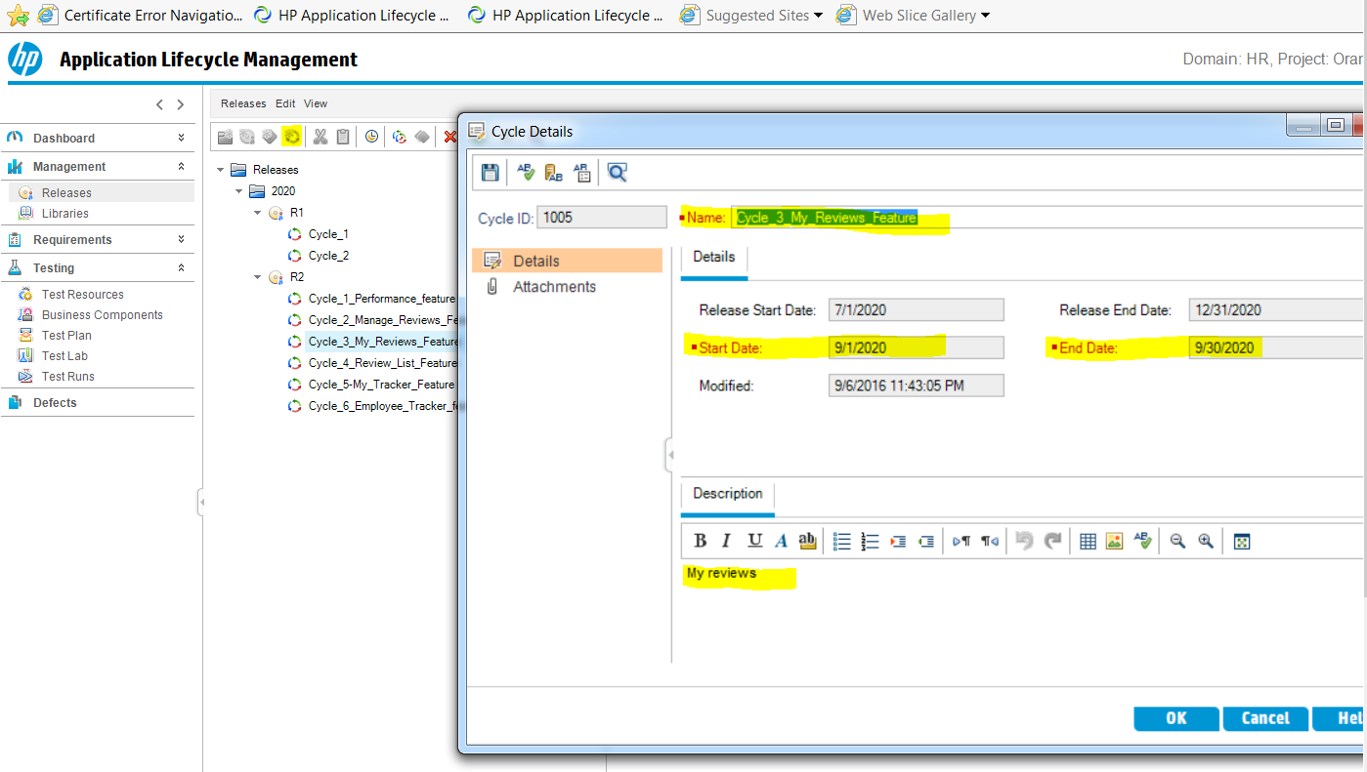

**CYCLE_4**

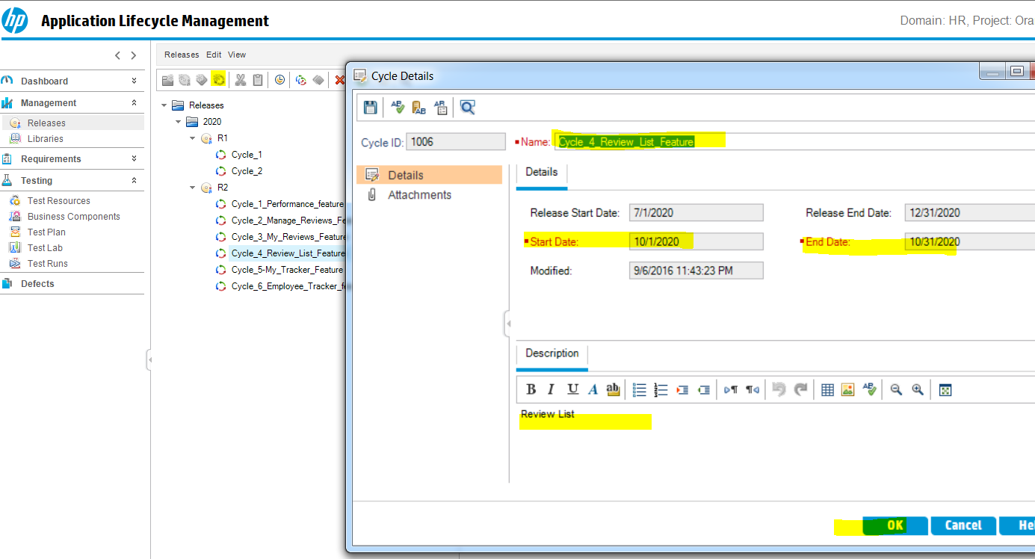

**CYCLE_5**

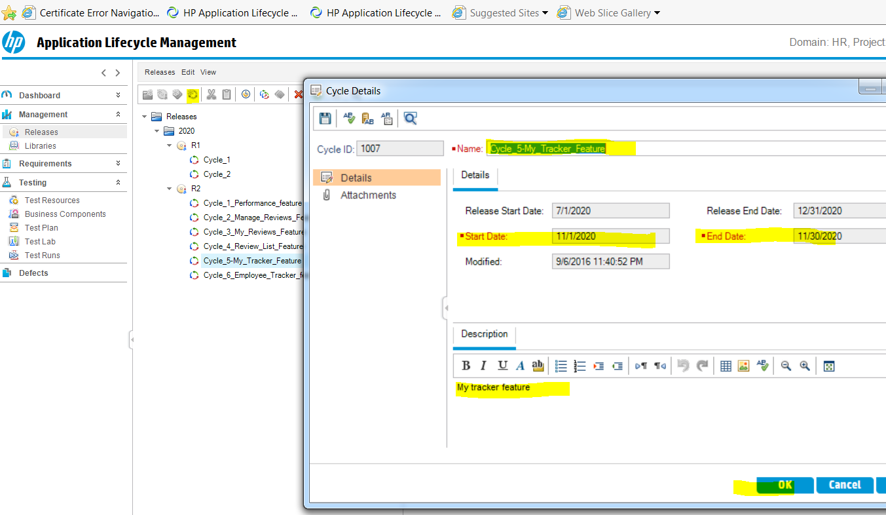

**CYCLE_6**

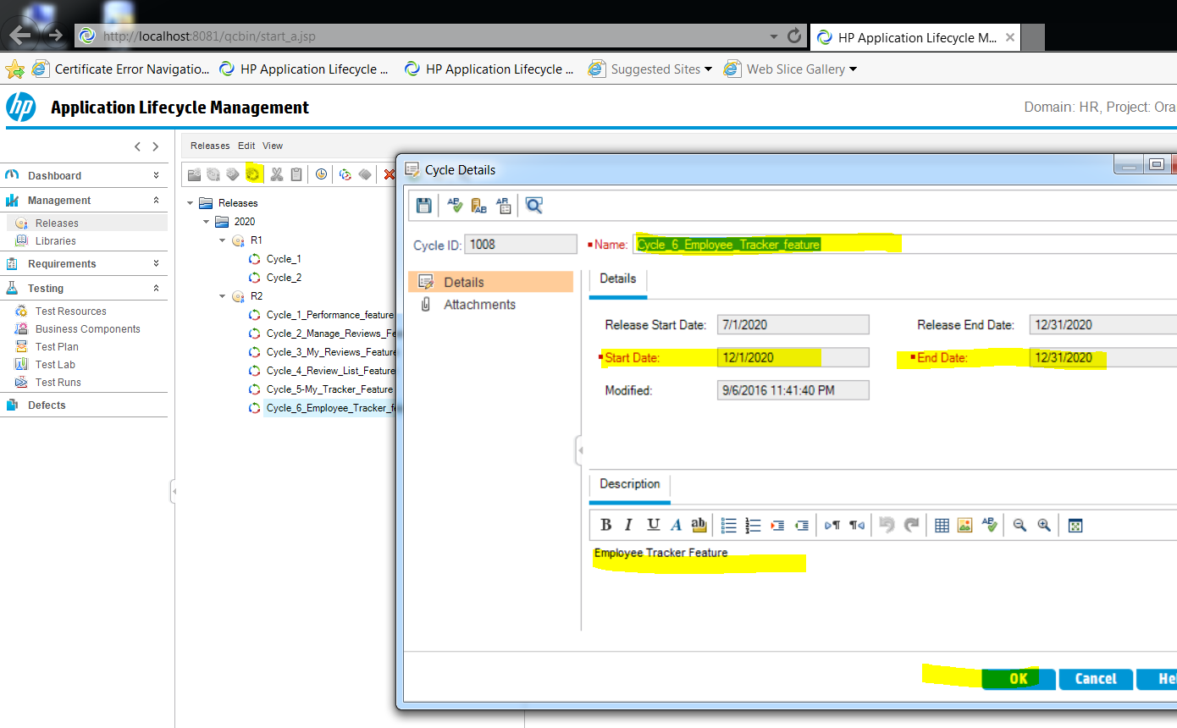

**17- So we created 6 cycles in Release2 that covers 6 feature per month**

**Click on R2 then Click on Master Plan**

**You will be able to see this**

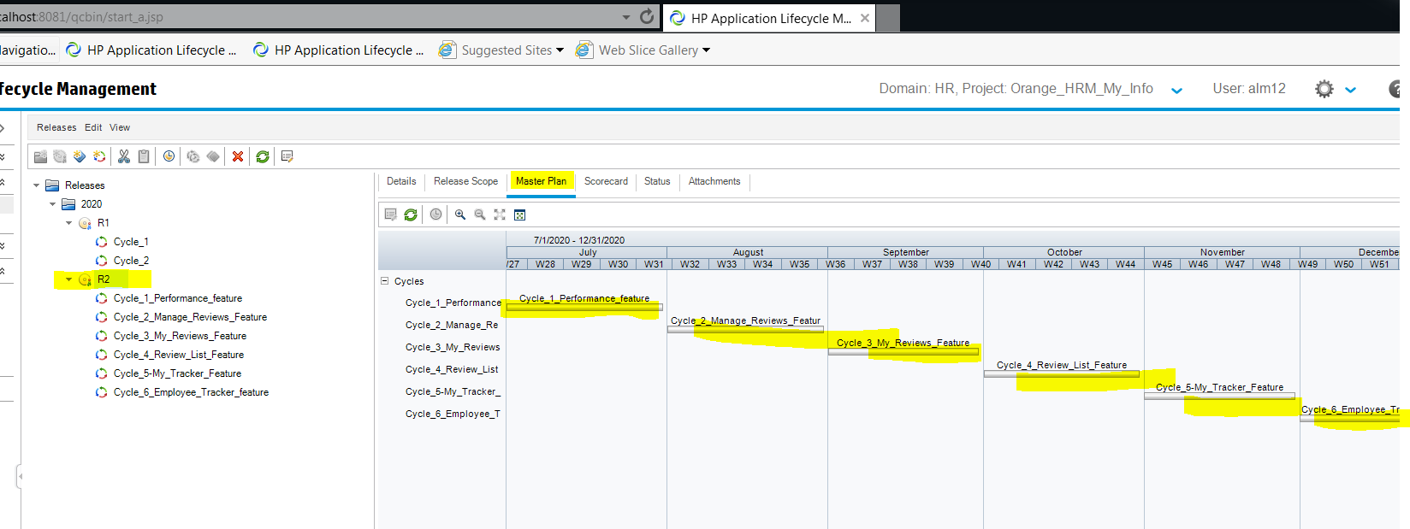

**18- Creating Requirement Folder**

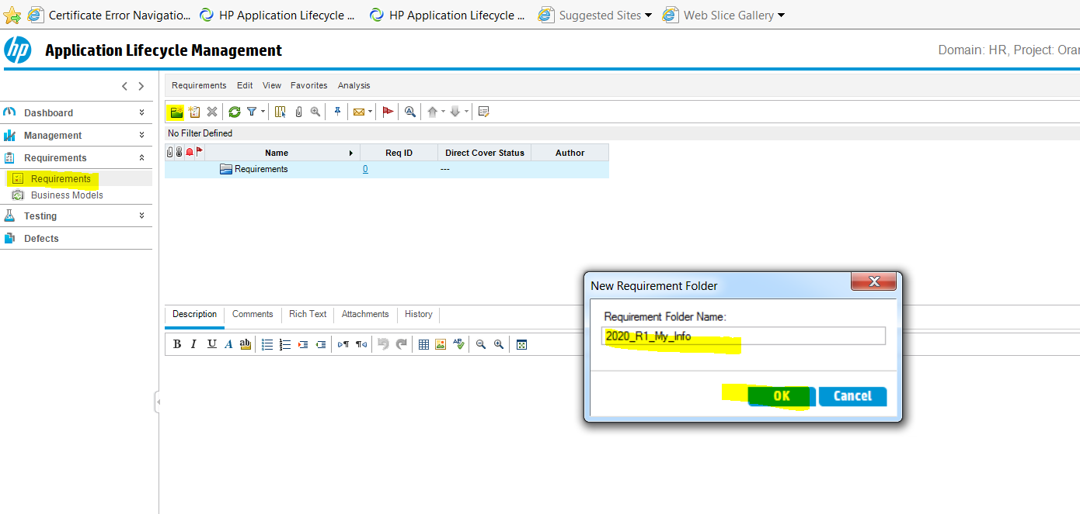

**19-Click on 2020_R1_My_info folder and again click on new folder to create sub folders underneath the 2020_R1_My_info**

**It can be functional and non-functional**

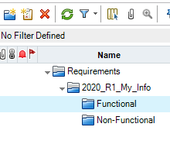

**20 – Create a Requirement**

**click on functional and press New Requirement icon to create a Requirement**

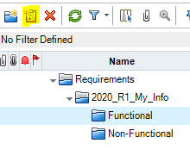

**21- enter the requirement details**

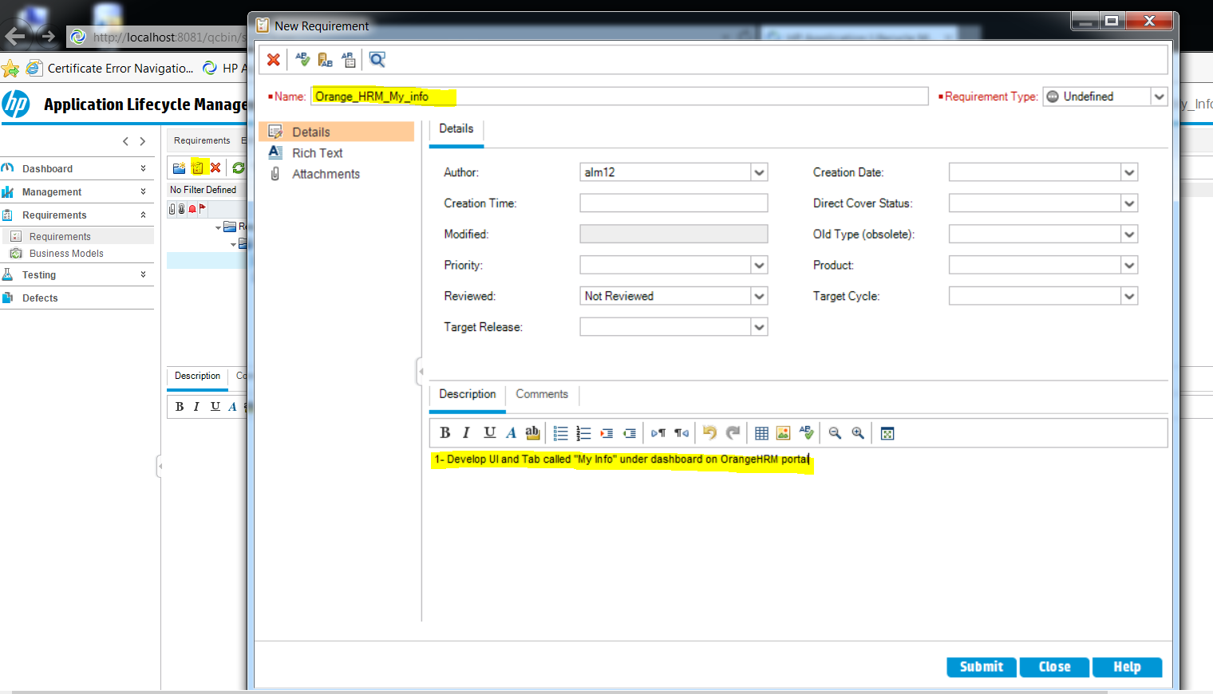

**22- You will select the Target Cycle by considering when this requirement will be developed in what cycle**

**In our case it will be Release1 and Cycle 1 and Cycle 2 so select the,**

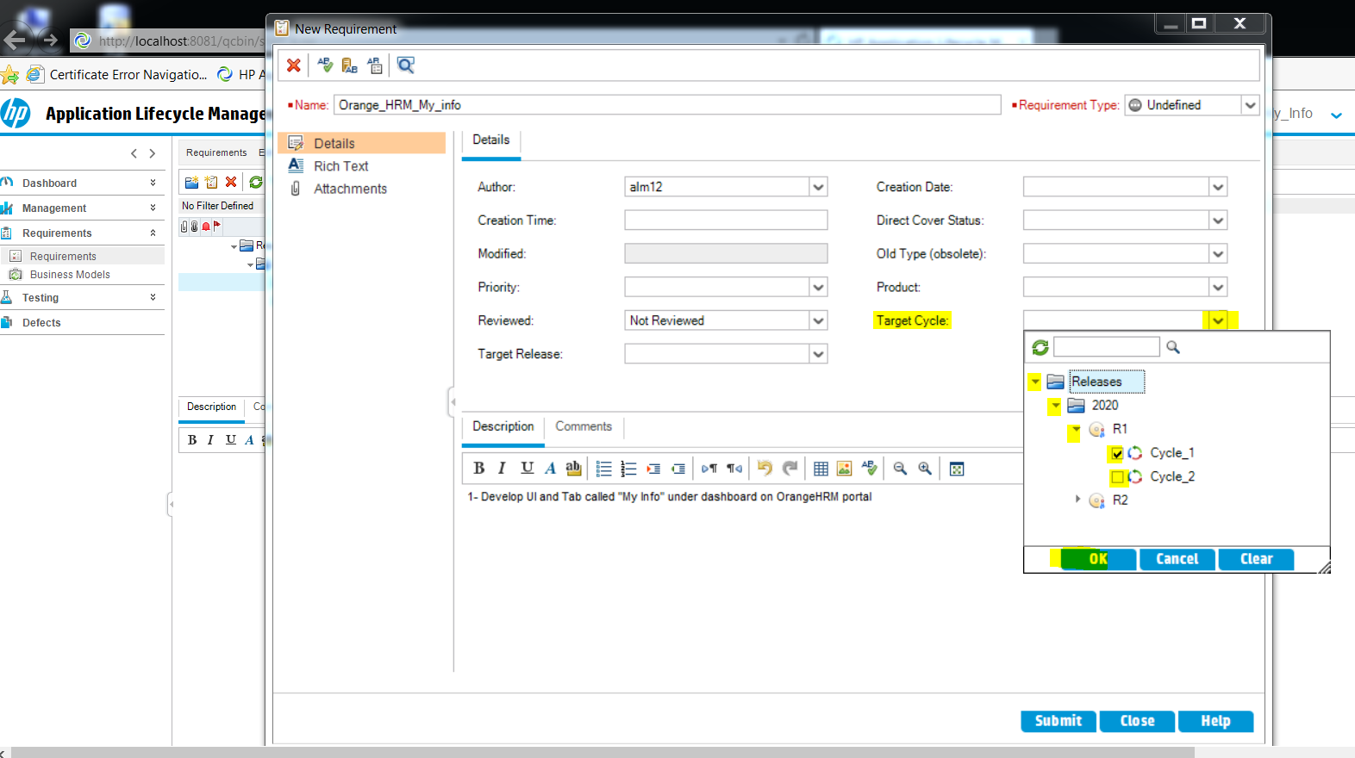

**23-Fill up the requirement details**

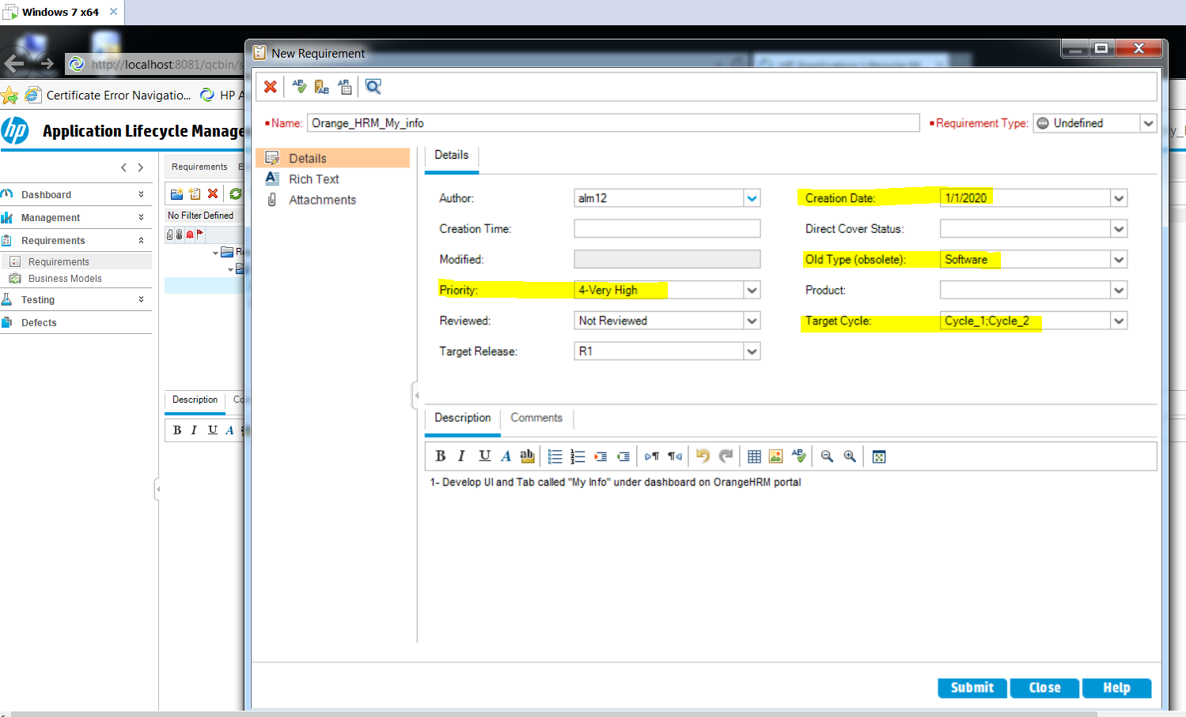

**24- Click on rich text document to add requirement details,**

**You can insert here text, pics**

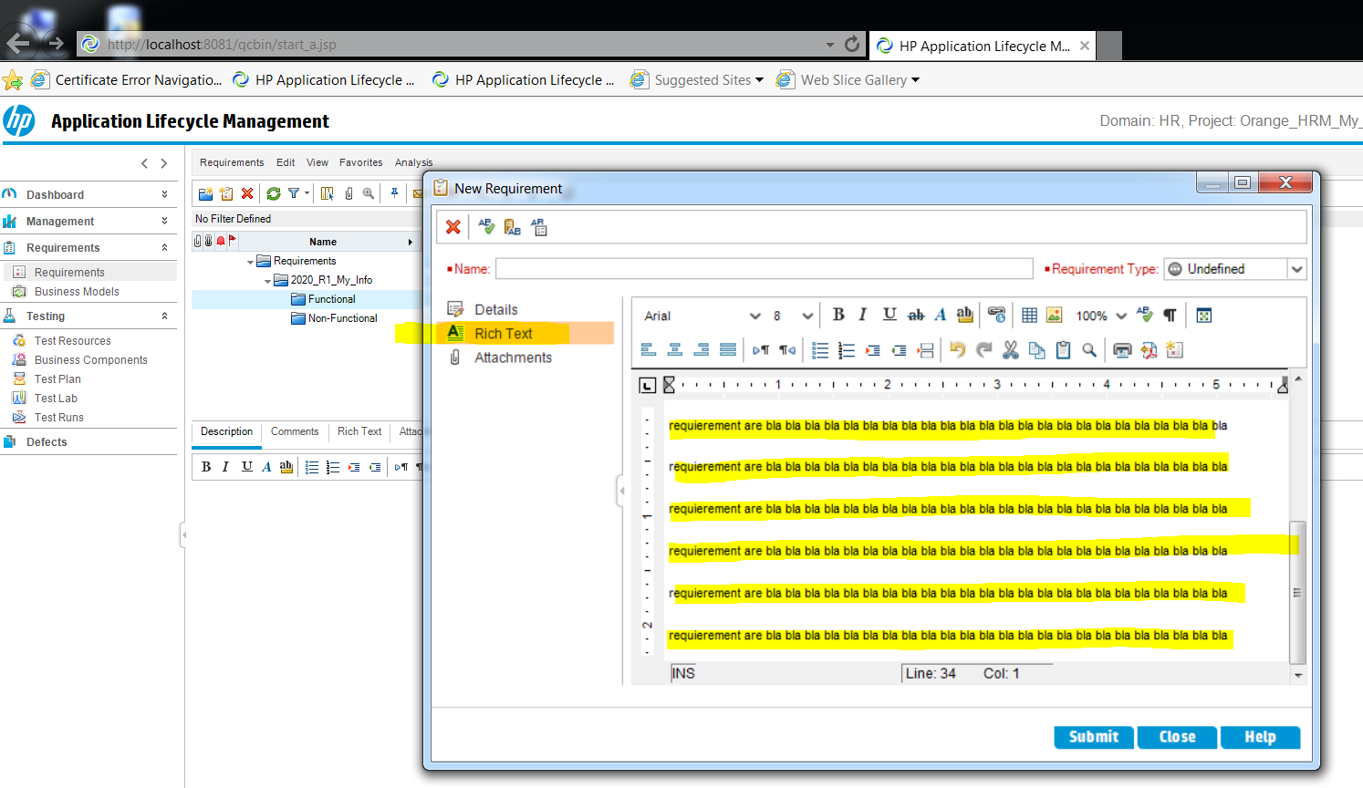

**25- Create functional requirement orange hrm my info**

**Then create some sub-requirements underneath the orange hrm my info**

**Bc my info include some different parts needs to be developed and tested**

**In this example first one is Performance Feature**

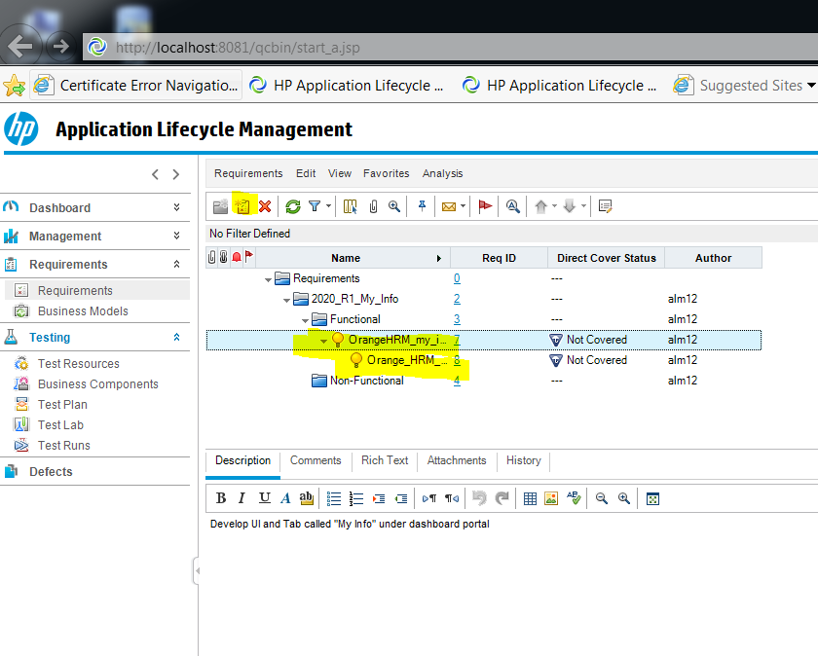

**26- how to create Test Plan**

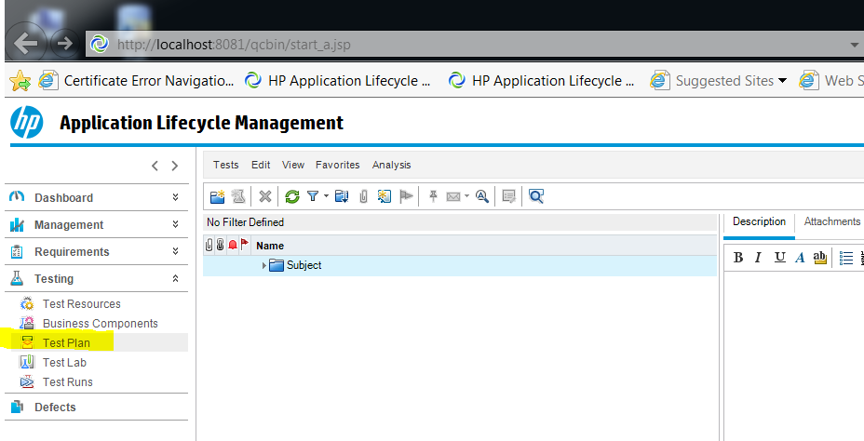

**27- then click on subject and click on new folder icon create folders for test plans**

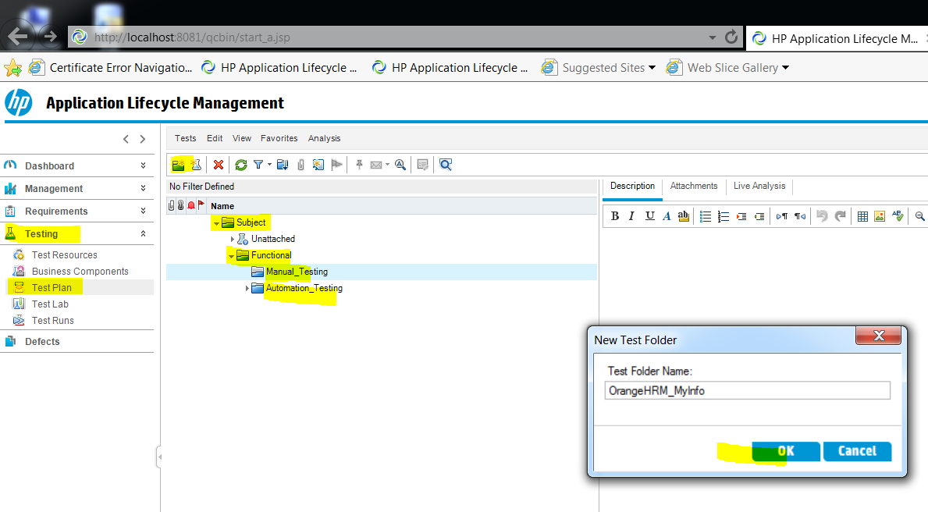

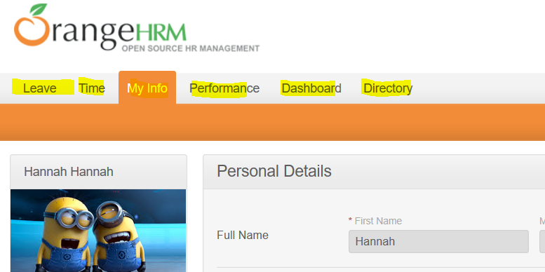

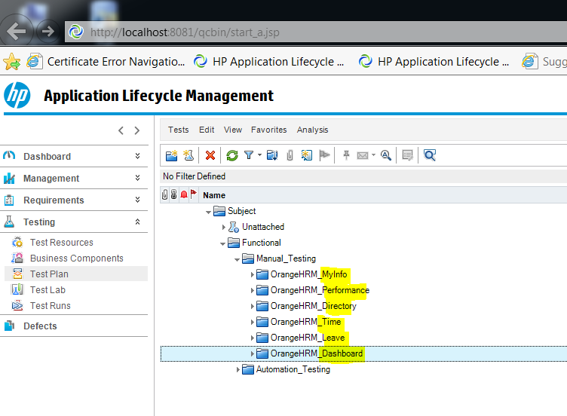

**28- how to create a test under a test folder**

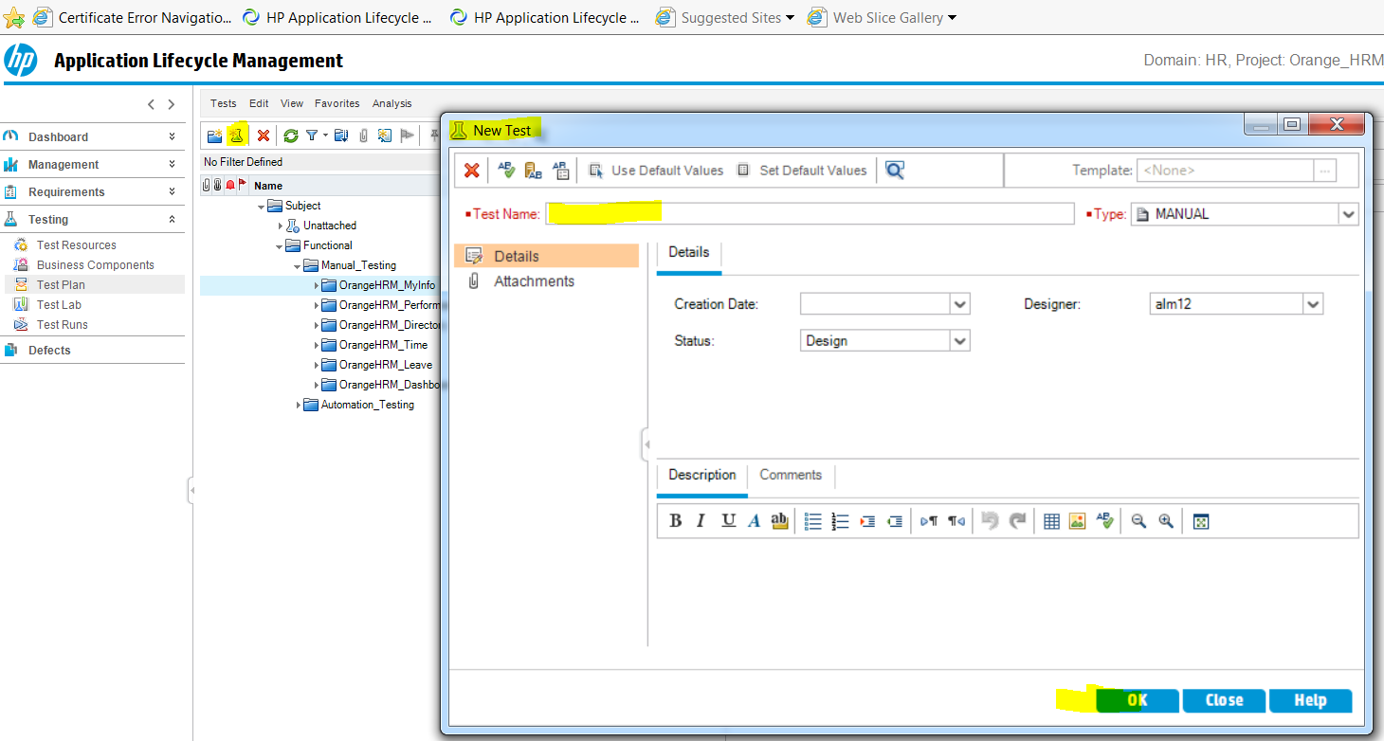

**29-Create the new test with info**

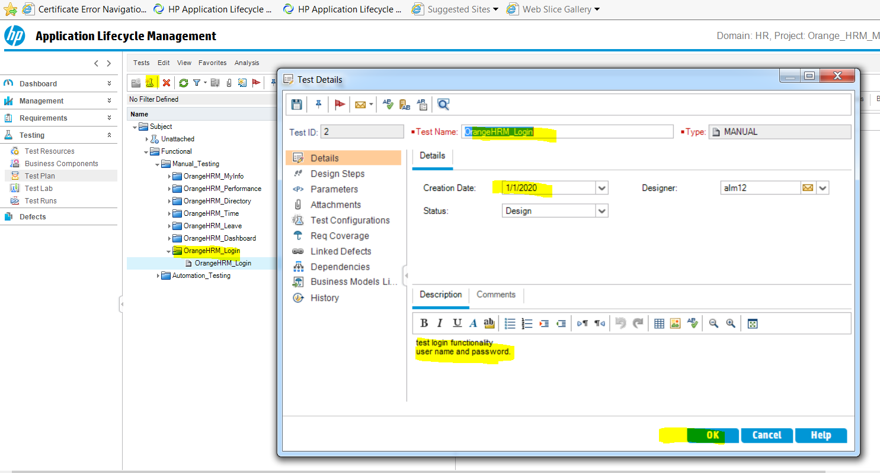

**30- Creating test steps under the test**

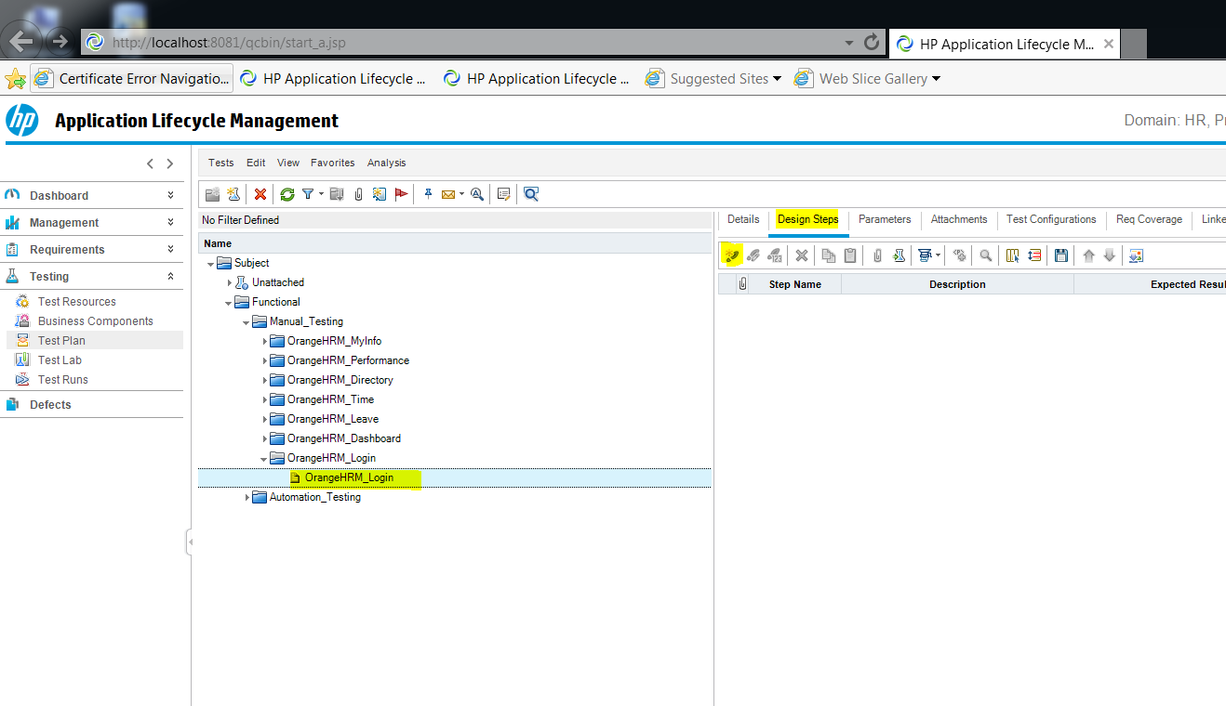

**31-Design steps then click on new test step icon**

**Enter the step and expected result and click ok**

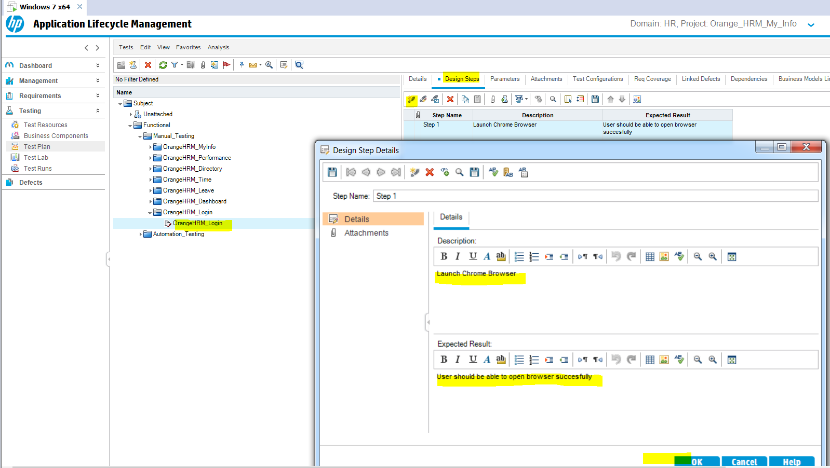

**32- complete all the test steps**

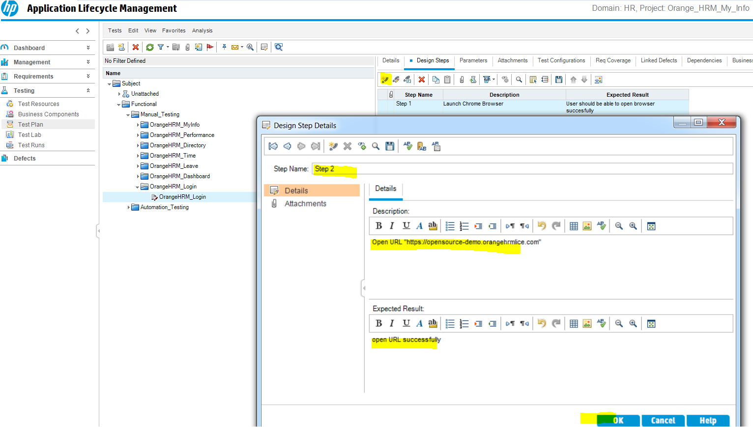

**33-create all the test cases then go to design steps and complete all**

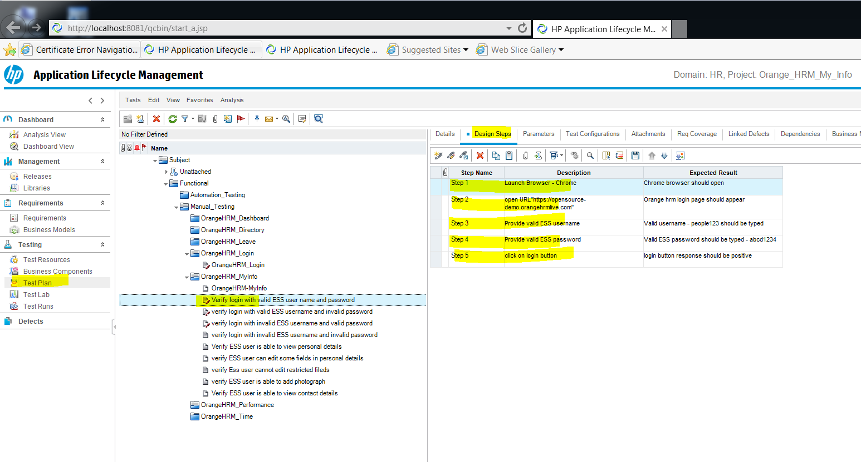

**34- go to test lab and create a test set and assign it to a cycle or sprint**

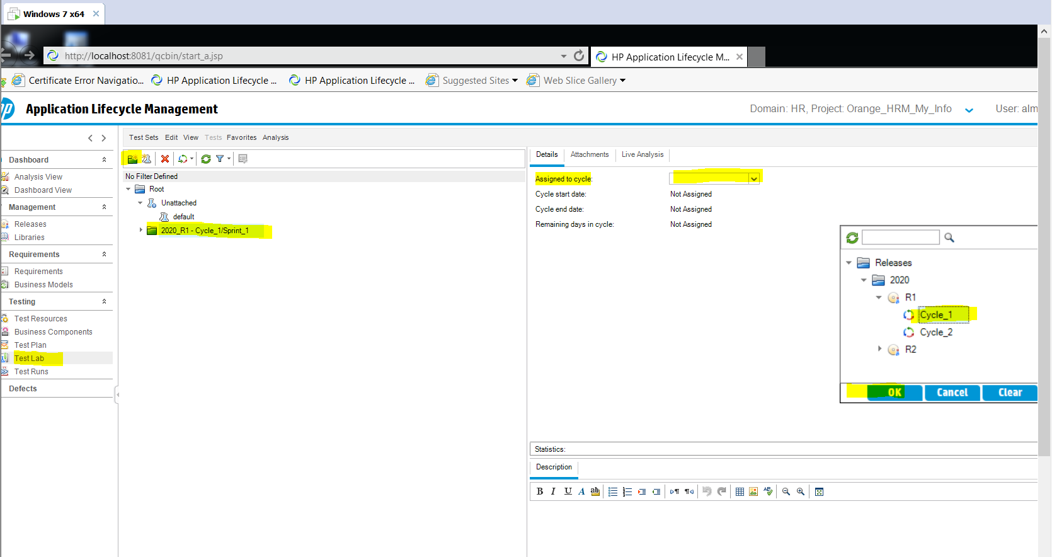

**35-create a test set and enter details**

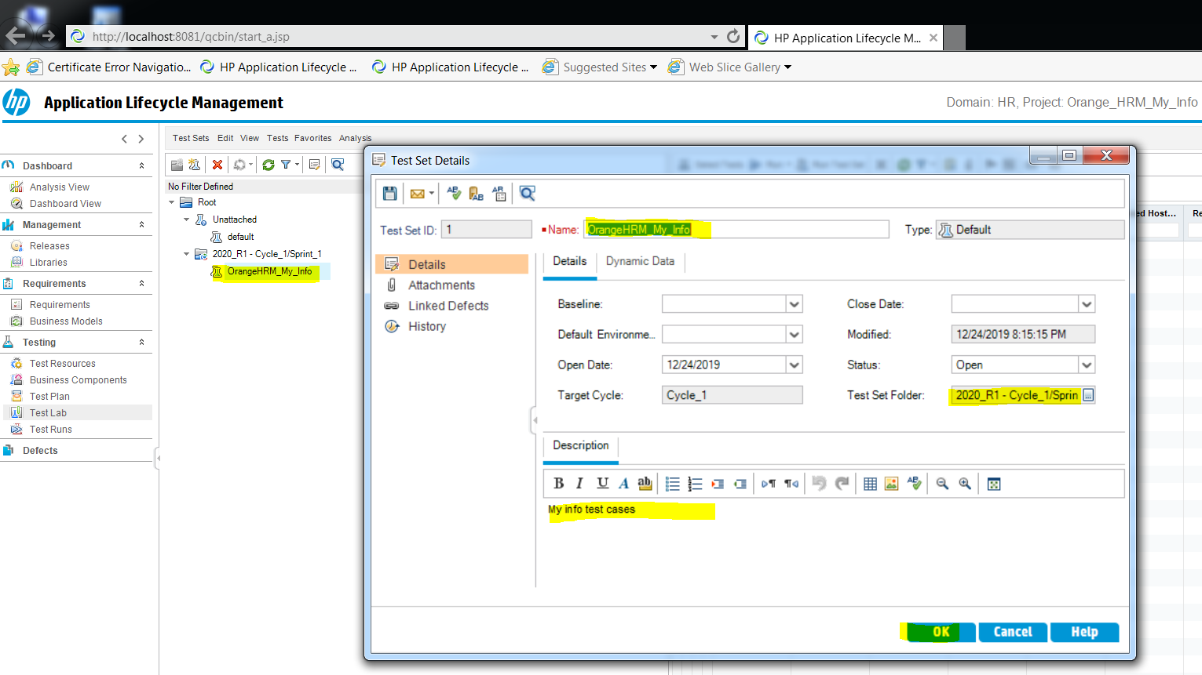

**36- then click on select tests and start adding your my info tests to your my info test set**

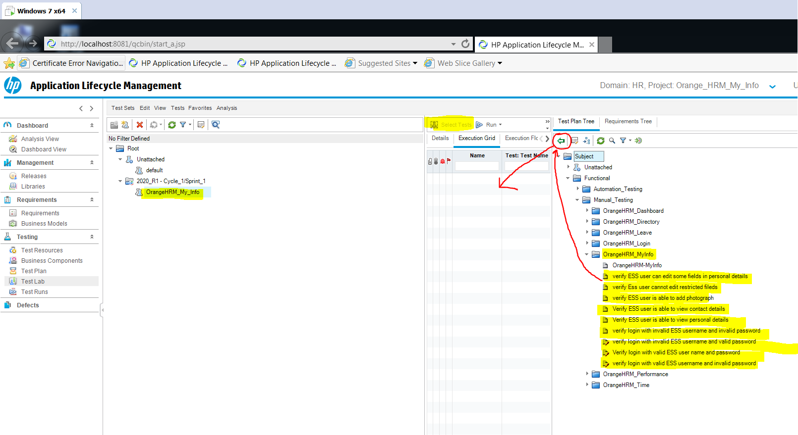

**All should be added on the left**

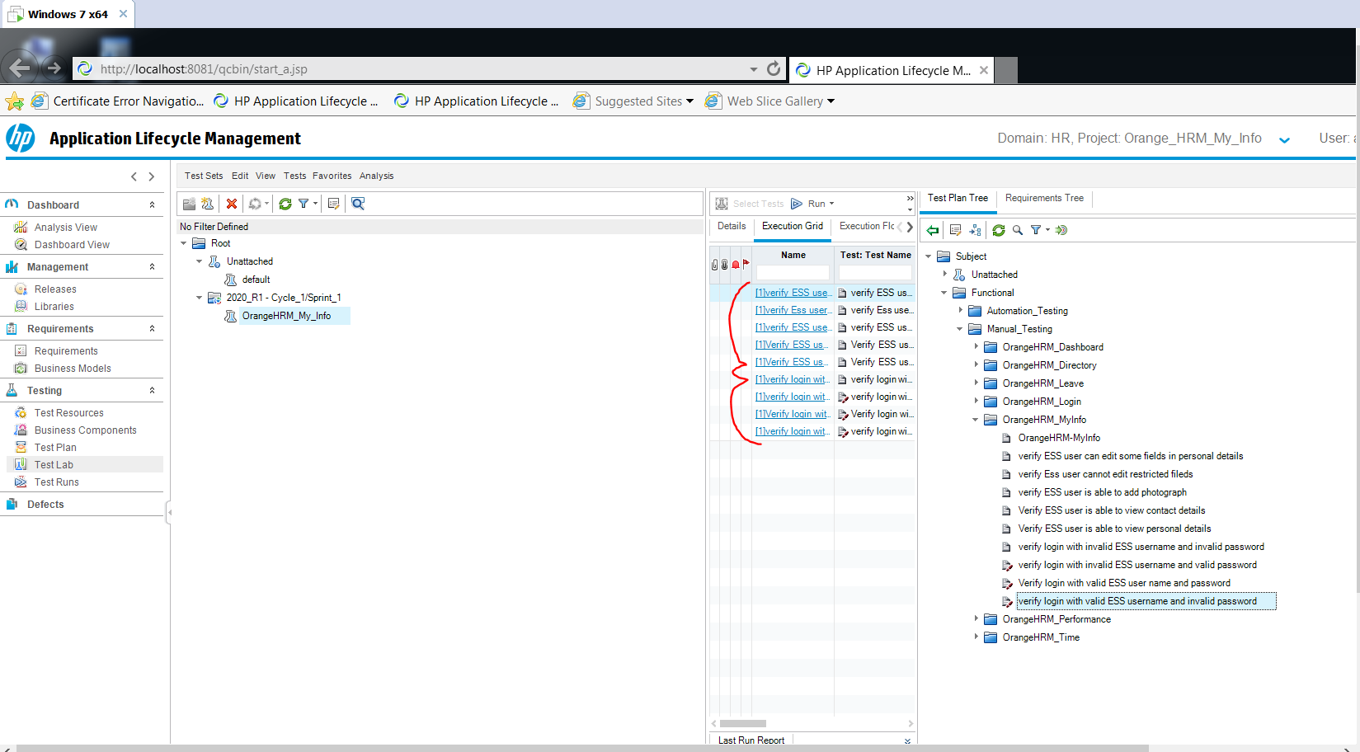

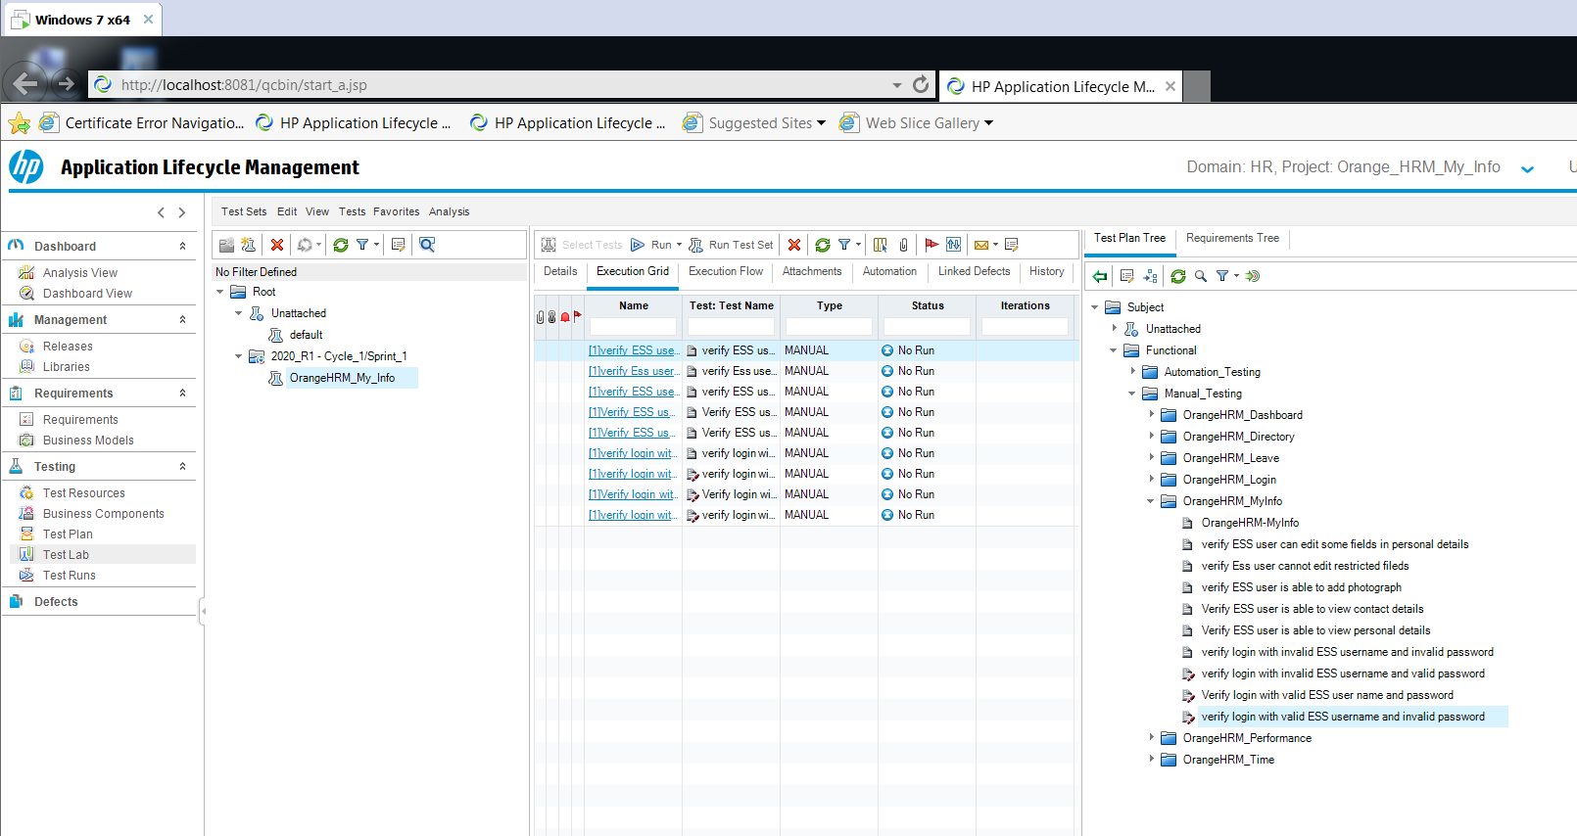

**Click on the specific test and click Run to run the test**

**Or you can click on run the test set to run all one by one**

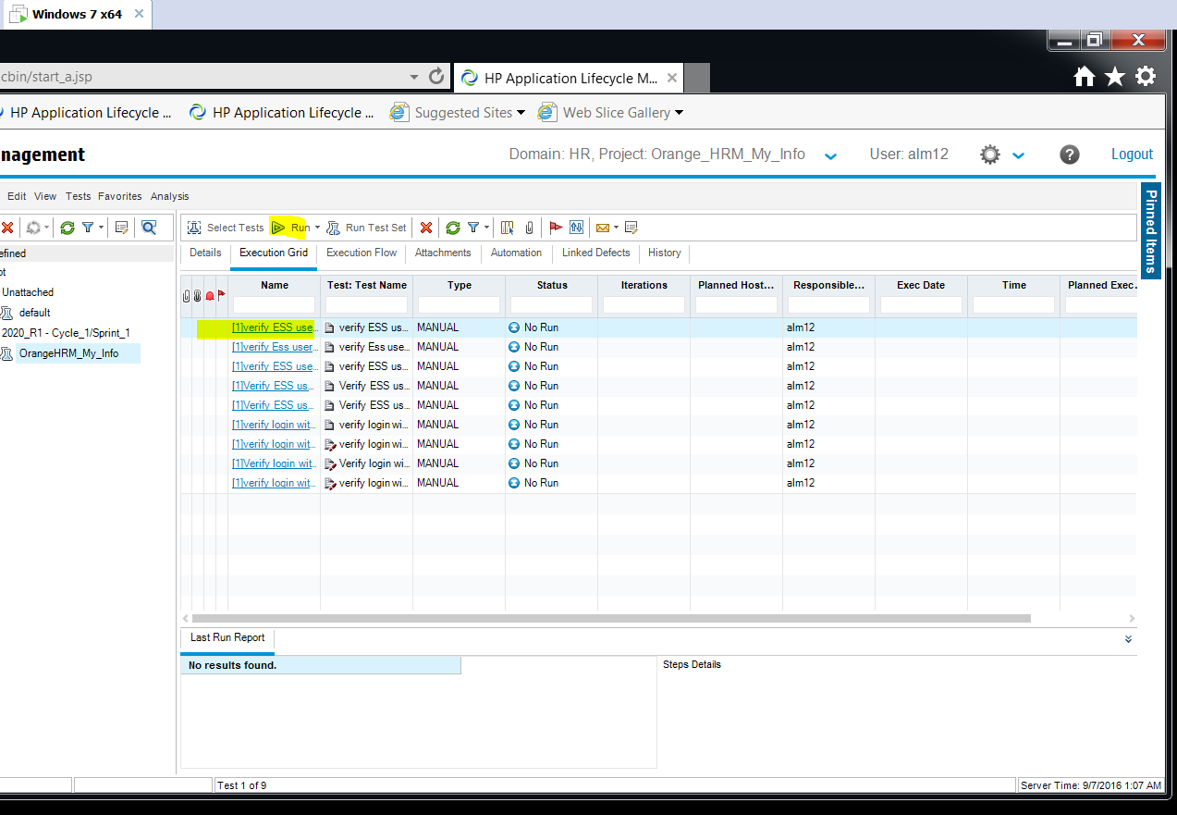

**Click on begin run**

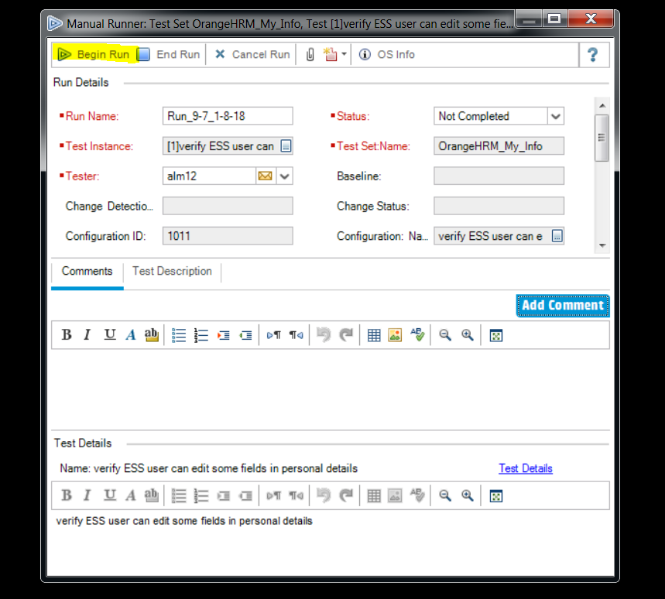

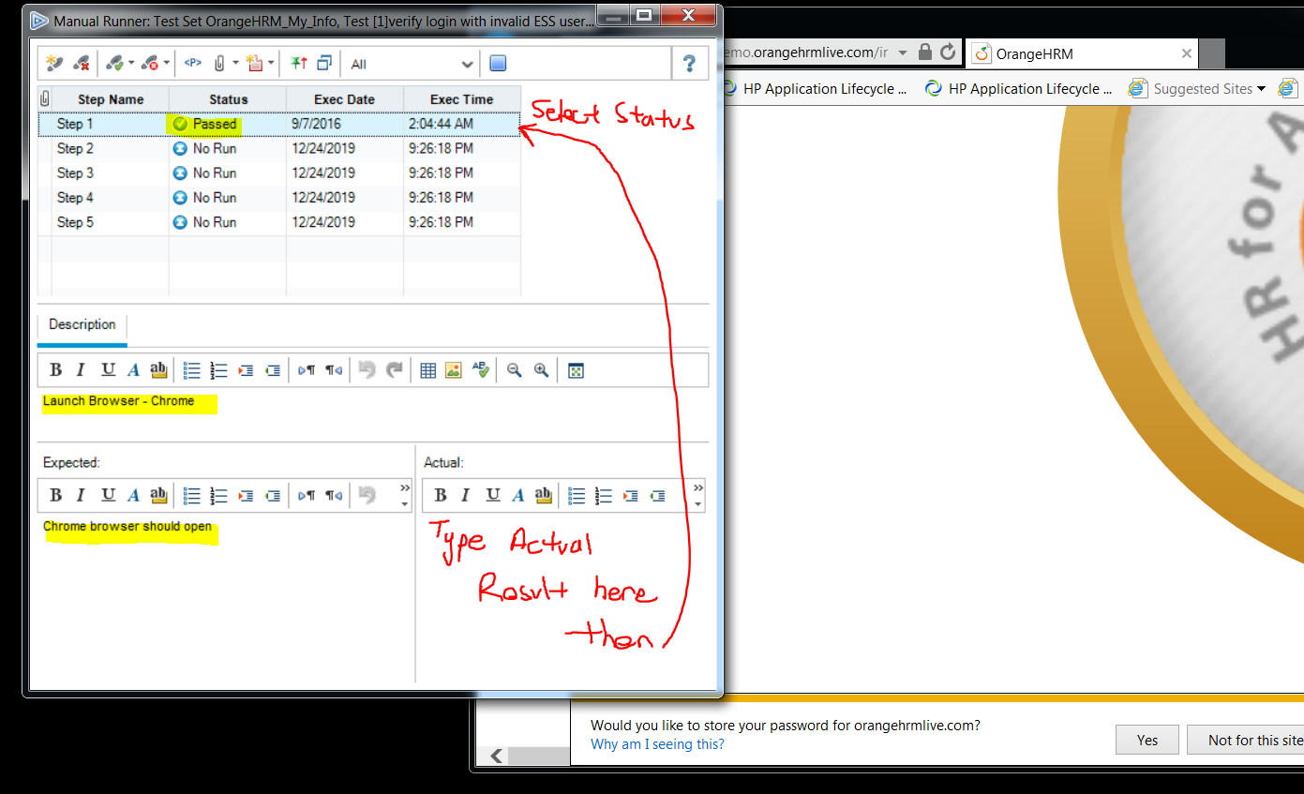

**You can view your runs from Test Runs Tab**

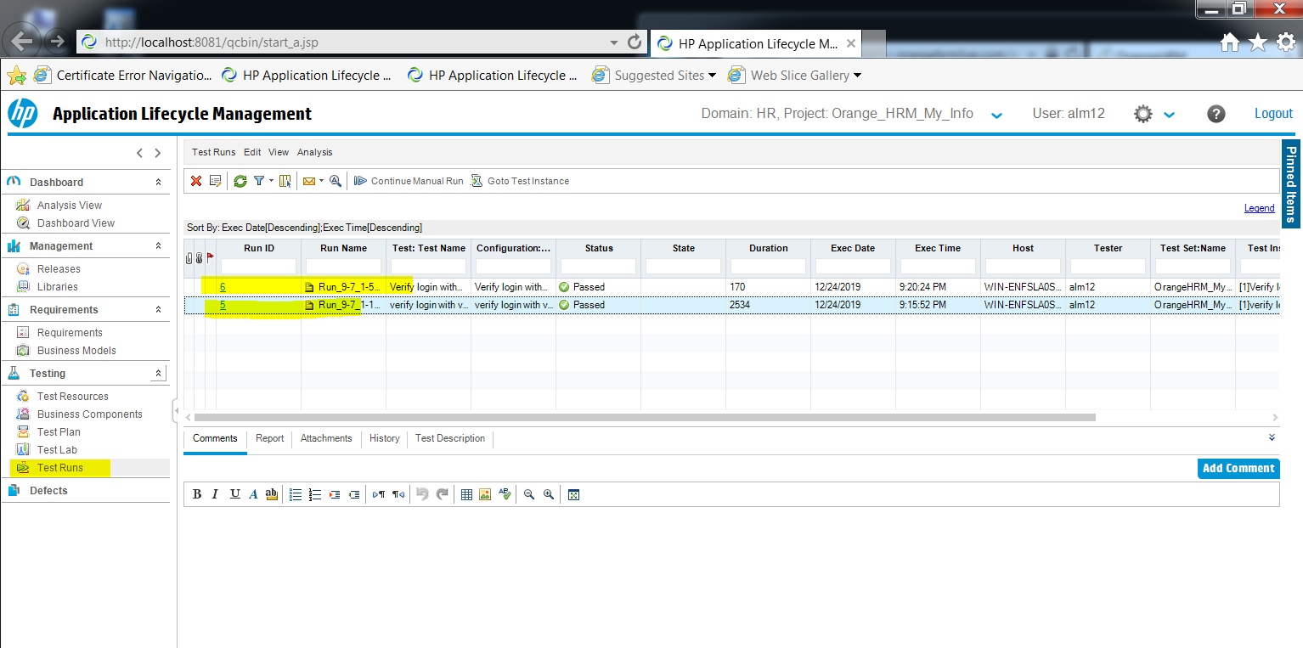

**To create reports from test plan tab**

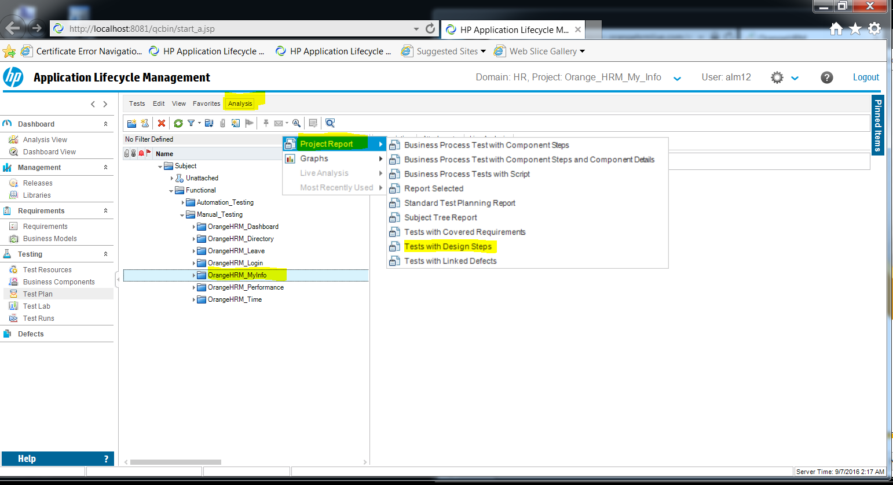

**Select tests with design steps**

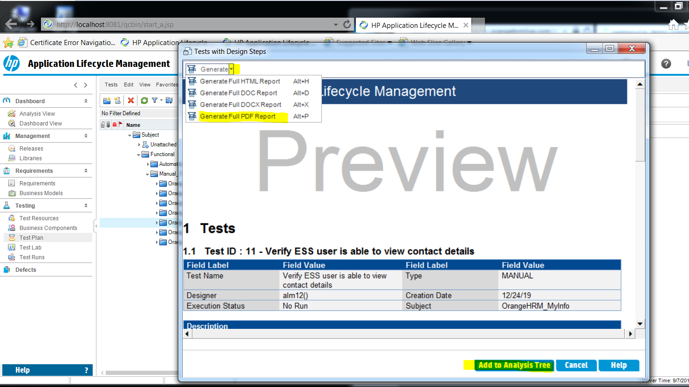

**To create a defect**

